Contents

1. The green transition as a pathway for a sustainable future 2
1.1 New political context and priorities 3
Competitiveness of the green transition 4
1.2 The green transition as response to global challenges 5
Tipping points: the need for accelerated actions 5
The costs of inaction 6
The effects of climate change on health 11
1.3 What people think about the green transition: the social perception of the EGD 14
1.4 Where we are: progress towards green ambitions 15
1.5 The green transition as a catalyser for achieving the Sustainable Development Goals 16

The costs of inaction
The "costs of inaction" refer to the economic, social, and environmental consequences of not taking measures to address climate change and environmental degradation. When assessing climate change and environmental policies, a comprehensive approach that accounts for both the costs and benefits of action and inaction is necessary. Such an approach allows for better informed decision-making, helps prioritize actions that minimize the risks and consequences of climate change, and can serve as a powerful motivator for individuals, organizations, and governments to take urgent and collective action to address the climate crisis and protect the environment. Moreover, considering the costs of inaction can also help to identify opportunities for cost savings and economic benefits associated with taking action.
Climate-related costs of inaction
To better understand costs of inaction, the pan-European climate risk assessment PESETA [9] is published regularly by the JRC, covering a wide range of climate impact categories. The methodology integrates a combination of state-of-the-art process-based and empirical models that translate high-resolution projections of climate conditions into biophysical and economic impacts. The cost of inaction refers to the simulated climate damages without any policy action, i.e. without adaptation or mitigation policies.
This section identifies projected damages under a 3°C global warming scenario as the “cost of inaction”. For few impact areas, 4°C scenario damages are also reported. Economic damage estimates consist of climate impacts that would occur by the year 2100. The JRC study provides results regarding climate impacts on people, the environment and the economy, with both biophysical and economic metrics. The consistent results summarised below refer to the eleven JRC PESETA IV project impact areas [10], [11] (human mortality from heat and cold waves, windstorms, water resources, droughts, river flooding, coastal flooding, wildfires, habitat loss, forest ecosystems, agriculture and energy supply) and the follow-up studies (e.g. labour productivity).
Preliminary results of the JRC PESETA V project are presented in figure 1, representing the additional economic costs (as a percentage of GDP) for the 2°C scenario by 2050 for the following impact areas: coastal floods, droughts, labour productivity, river floods, transport infrastructure, windstorms and energy demand. The burden of climate change shows a clear north-south divide, with southern regions in Europe impacted relatively more and, particularly, southern-eastern regions. That spatial pattern is due mainly to consequent changes in high-end temperatures and the spatial and temporal availability of water.
Figure 1. Additional economic costs for 2°C scenario by 2050, as a share of GDP (coastal floods, droughts, labour productivity, river floods, transport infrastructure, windstorms and energy demand)
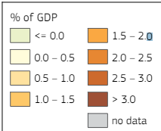
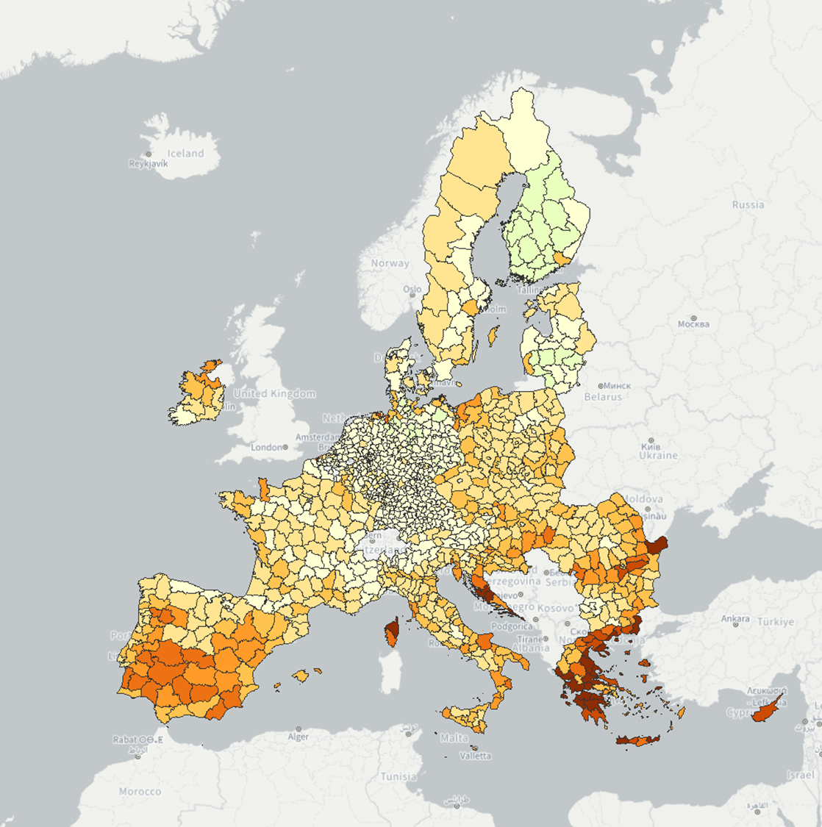
Source: 9th Cohesion Report, European Commission (2024).

The main results for the 3°C temperature degree scenario follow.
Climate impacts on people
- Temperature-related deaths could increase by around 55,000 additional deaths by 2100, driven by rising heat-related deaths and an ageing population. Climate change is also expected to widen disparities in regional mortality, particularly impacting southern regions of Europe as a result of a marked increase in heat-related deaths.
- Around 450,000 people would be exposed to river flooding each year, or nearly three times the number at present.
- 1.4 million people would be exposed per year to coastal inundation compared to around 70,000 at present, i.e. a 20-fold increase.
- An additional 15 million Europeans living in the proximity of wildland would be exposed to high-to extreme fire danger for at least 10 days/year.
- Water resources availability would drop by up to 40% in Southern regions of Europe and droughts would happen more frequent in most of Southern and Western Europe.
Climate impacts on the environment
- The Alpine tundra domain would contract by 84% and practically disappear in the Pyrenees. The natural climatic tree line would shift vertically up by up to 8 m/year.
- Ecological domains would shift northwards, resulting in severe changes of the prevailing domains in southern Europe and Boreal areas and the encroachment of the Tropical domain in Europe.
- Wildfire and pest outbreaks will become more frequent and severe, increasing biomass loss and additional carbon release (and warming).
Climate impacts on the economy
- River flood losses would rise 6-fold in magnitude, reaching 43 €billion/year with 3°C.
- Coastal flood losses would grow by two orders of magnitude and climb to 200 €billion/year, from 1 €billion today.
- Drought losses would increase to nearly 41 €billion/year with 3°C warming (60 €billion/year with 4°C warming), compared to around 8 €billion/year at present.
- Water scarcity and drought would increasingly affect agriculture, energy production and water supply in regions that already suffer from water stress.
- Labour productivity could be 0.7% lower in Europe, compared to nowadays.
- There would be a regional redistribution of tourism demand within Europe, with also relative reductions in summer and increases in the shoulder and winter seasons.

Key impacts not considered in the JRC PESETA assessment include those related to the irreversible damage to nature and species losses, aquatic and marine ecosystems, water- and vector-borne diseases, air quality, displacement of people, conflicts and security, and the potentially daunting consequences of passing climate tipping points. The extent of extreme events are also not fully captured, such as those of heat stress on crop yields and droughts on energy production. Cascading climate effects across sectors and from the rest of the world are also poorly understood.
This implies that the biophysical and economic impacts reported in PESETA represent just a lower bound of the cost of inaction for Europe. Furthermore, the assessment does not consider other fundamental cost categories indirectly associated to climate inaction: high energy supply vulnerability (notably higher energy import bill and the associated potentially large macroeconomic costs in terms of economic growth, inflation and employment), higher air pollution and security issues (e.g. migration).

Biodiversity related cost of inaction
On top of the cost associated to a delay in preparing the EU to climate change, there is a considerable cost of inaction when it comes to protect and restore biodiversity. In fact, nature provides benefits to people and economy through ‘ecosystem services’ – such as the pollination of crops, protection of coasts from flooding and erosion, supply of fresh water, wood production, marine fisheries and carbon sink and storage. As the natural assets (such as forests, wetlands, coral reefs and seas) that provide these services decline, the economic burden on societies increases (including GDP, trade, and production and commodity prices).
Financial resource to protect and restore the planet’s more fragile natural resources currently amounts to $166 billion per year globally (for comparison, less than one-sixth of the annual investment in the greening of the energy system [12]), but it will need to increase to about $1 trillion globally by 2030 [13]. While this is a sizable sum, it pales in comparison to the anticipated economic cost of biodiversity loss by the end of the decade. Even by the World Bank’s conservative estimates, the deterioration of natural processes like wild pollination and resources like marine fisheries could see global GDP come in $2.7 trillion a year lower than projected levels by 2030.
Similarly, a detailed report [14] by WWF concluded that, “unless we reverse nature loss, trillions of dollars” (globally) “will be wiped off the world’s economies, industries will be disrupted and the lives of millions will be affected”.
The study calculated the reduction of supply of six ecosystem services in a ‘Business-as-Usual’ scenario, which would lead to an annual loss of US$ 479. Over the period between 2011 and 2050, the total cumulative loss would be US$ 9.87 trillion (3% discount rate). These figures should be considered highly conservative and should not be considered an assessment of the total costs of nature’s loss, since the current model only considers six of the many ecosystem services provided by nature (those for which there is enough evidence to quantify). Nor does it account for the potential effects of ‘tipping points’.
As a consequence of a decrease of ecosystem condition and hence in ecosystem services, the world’s agricultural sectors will be hardest hit by the loss of nature’s benefits, and the prices of several basic commodities will increase.
In Europe, biodiversity is in rapid decline and the economic picture is aligned with the global one. Economists estimate the loss of biodiversity in Europe costs the EU around 3% of GDP per year and global biodiversity loss is valued at around €50bn. Crop pollination alone is worth more than €14bn annually, while wetlands provide an estimated €6bln in ecosystem services each year [15]. The INCA project (implemented at JRC) delivered an estimate of the monetary value of ESS in Europe [16].
Acting to restore and conserve our natural environment is clearly a worthwhile investment and should be thought of as a “cost.” Failure to act would, however, come with a significant price tag for the economy and society. For example, managing the Natura 2000 network requires an investment of around €5.8bn per year, but it generates €200bn to €300bn per year in economic benefits, according to European Commission figures.
Ensuring more effective implementation of EU Nature Directives at national and regional level, and placing greater importance on the value of our natural capital, as aimed in the EU Regulation on Nature Restoration, would have considerable benefits for biodiversity, sustainable economic development and Europe’s prosperity.
To this goal, the Biodiversity Finance Factbook [12] identifies six overriding tasks that governments, companies, and financial institutions must address:
- Back initiatives to collect and share biodiversity data and harmonize metrics and frameworks.
- Integrate biodiversity into planning, operations and reporting.
- Reform environmentally-harmful subsidies and boost biodiversity support.
- Develop replicable business models and use concessional funding to address the dearth of bankable biodiversity projects.
- Improve the environmental integrity of offsets and other mechanisms.
- Promote industry and local community buy-in.

